Dual Shaft Rewinding Machine ZRFJ-1300-D250
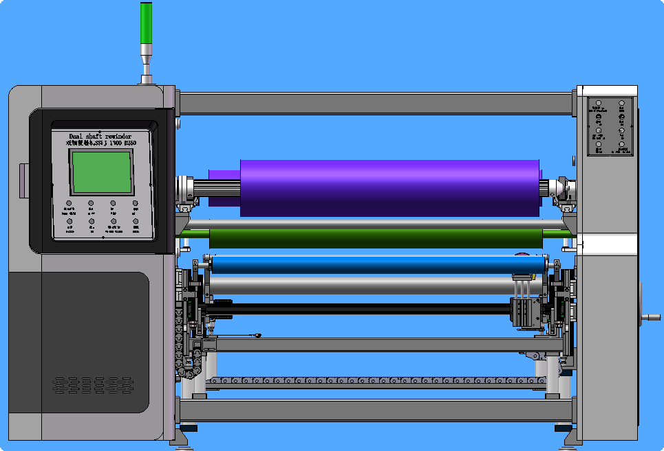
Equipment Layout：
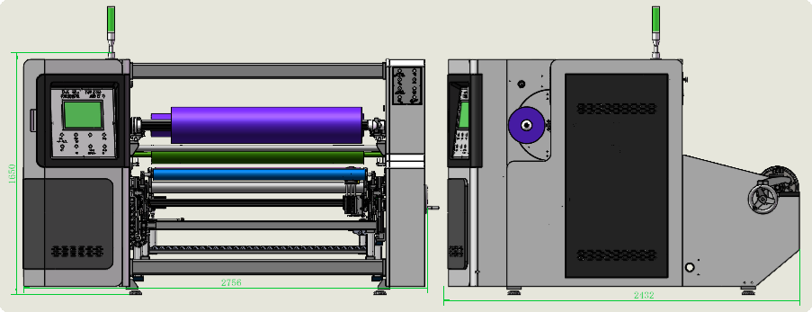
Basic Use：
Mainly used for adhesive rewinding of automotive foam, foam double-sided tape, BOPP tape, masking tape, double-sided tape and other materials.

Equipment Advantages:
- Equipped with Hechuan motion control system to realize automatic taper tension. Different tension is generated according to material thickness and winding diameter during rewinding.
- The active traction adopts 5.5kW servo control. The rewinding length accuracy is within 5mm-10mm. It is applicable to unwinding with high/low tension and enables continuous, long-term stable operation.
- Automatically shifting electronic pressure roller: automatically adjusts following the set material thickness, material thickness variation and length change. It maintains the gap between pressure roller and winding shaft, delivering flatter finished rolls with consistent tension tightness for various roll diameters.
- Automatic tension winding & unwinding with stable tension and smooth start-stop. Servo motor torque winding ensures stable and precise tension for neat rolls with flat end faces.
- The glue roller surface adopts nano-coating; all back-up rollers are mirror finished to avoid scratching materials. All pressure rollers are made of silicone rubber.
- Curved spread roller flattens various materials, enabling efficient high-speed rewinding.
- Dual-shaft winding with roll flipping function; manual cutting and tape splicing. The tail pressing roller automatically flattens materials to improve productivity effectively.
- The material suction worktable features automatic suction during manual cutting, facilitating material joining and tape splicing.
- 10-inch touch screen for simple and intuitive operation.
- Working width can be customized according to materials, models available: 1100, 1300, 1600, etc.
Main Technical Parameters：
Model | ZRFJ-1300-D250
Paper core | Customized as customer requirements (Interchangeable)  25/38/50/76
Unwinding master roll | Max. Diameter 800mm
Rewinding diameter | 250mm
Rewind width | 1300mm
Production speed | Line Speed200m/min  4-5pcs/min（15m）  Subject to rewinding length
Power supply | 380V 50/60HZ/18KW
Machine size | 2800*2500*1600mm
Net Weight | 1.2T

Configuration Parameters：
Model | ZRF-1300-D200
Touch Screen | 10-inch MCGS
Frame Wall Plate | 25mm
Motion Controller | HCFA
Active Traction Servo Motor | 5.5kwHCFA
Active Traction Servo Driver | 5.5kwHCFA
Winding Pressure Roller Servo Motor | 1.5kwHCFA
Winding Pressure Roller Driver | 1.5kwHCFA
Winding Servo Motor | 4.4kwHCFA
Winding Servo Driver | 4.4kwHCFA
Roll Flipping Servo Motor | 1kwHCFA
Roll Flipping Servo Driver | 1kwHCFA
Tail Winding Servo Motor | 1kwHCFA
Tail Winding Servo Driver | 1kwHCFA
Key-type Unwinding Air Shaft | 3inch
Plate-type Winding Air Shaft | 3inches
Motor | MaiLi
Planetary Reducer | Smetre
Magnetic Powder Brake | WREZUN
Air Circuit Breaker | chint
Switching Power Supply | Mingwei
Photoelectric Sensor | BOJKE
Proximity Switch | Yangming
AC Contactor | Schneider
Relay | IDEA
Push Button Switch | Schneider
3-color Warning Light | TAYB
Solenoid Valve | ASICKO
Air Cylinder | AIRTAC
Linear Guide Rail | HIWIN
Magnetic Switch | AIRTAC
3-inch Key-type Unwinding Air Shaft | Taiwan
Bearing | NSK
Dual Traction Main Shaft | Nano-coating Anti-sticking Treatment
Winding Pressure Roller | Φ180mm Silicone Pressure Roller
Transition Roller | Hard Anodizing, Brown Finish
Tail Pressure Roller | Φ80mm Silicone Pressure Roller
Traction Pressure Roller | Φ80mm Silicone Pressure Roller
Machine Body | Spray Coating & Baking Finish

